**Permintaan Data & Perubahan Data**

**Agnes calista - 2501980690**

**input secara manual**

insert into dbo.Student (Student_ID, Name, Program_of_Study, GPA) values

('36008','Andrea Baker', 'Marketing', '3.0'),

('61559', 'Rebecca Parker','Computer Science', '4.0'),

('72596', 'Laura Murray', 'Mathematics','3.0' ),

('40574', 'Linda Hines', 'Computer Science', '3.6'),

('89832', 'Jasmine Fletcher', 'Accounting', '2.3'),

('35750', 'Dylan Rangel', 'Art Education', '3.0'),

('68389', 'William Velez', 'Mathematics', '3.3'),

('20212', 'Steven Murphy', 'Computer Science', '2.0'),

('87006', 'Michael Moore', 'Art Education', '4.0')

CREATE table [Student_Profile](

[Student_ID] int,

[Name] varchar(50) ,

[Email_Address] varchar(220),

[Phone] int,

[Address] varchar(220),

[City] varchar(200)

)

Untuk mempercepat proses penginputan data dari Excel ke database, langkah-langkahnya sebagai berikut:

1. Simpan data dalam format CSV.
2. Klik kanan pada database yang sudah dibuat.
3. Pilih opsi "Task".
4. Pilih "Import Flat File".
5. Pilih file CSV yang telah disimpan sebelumnya.
6. Sesuaikan tipe data dengan data yang ada. Misalnya, kolom "name" bisa menggunakan tipe data "varchar", dst.
7. Setelah itu, klik "OK".

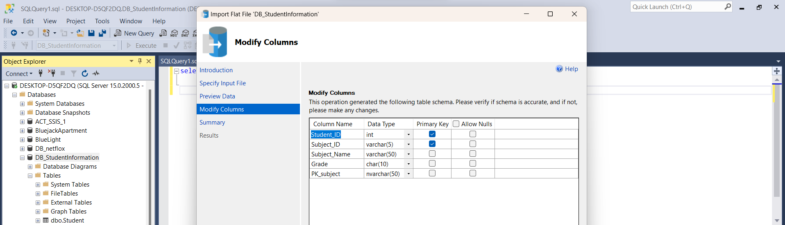

Figure 1.

Dengan mengikuti langkah-langkah yang telah disebutkan sebelumnya, data dapat dengan cepat dimasukkan ke dalam database tanpa adanya kesalahan input. Dengan menyimpan data dalam format CSV dan menggunakan fitur "Import Flat File" pada database,

Figure 2.

Link referensi: <https://youtu.be/JVP9frj2VSQ>

**Soal No 1**



Figure 3.

**🡪Jawaban :**

select S.Student_ID,S.Name,Program_of_Study, Email_Address,Phone, Address, City from Student S

join [dbo].[student Profile] as SP on SP.Student_ID = S.Student_ID

join [dbo].[Student Subject] as SS on SS.Student_ID = S.Student_ID

where City = 'Kingston'

Figure 4.

**Soal No 2**

SELECT "Subject A" GRADE for Computer science student

**🡪Jawaban :**

-- 2

select S.Student_ID,S.Name,Program_of_Study, Subject_Name, Grade, Address from Student S

join [dbo].[student Profile] as SP on SP.Student_ID = S.Student_ID

join [dbo].[Student Subject] as SS on SS.Student_ID = S.Student_ID

where Subject_Name = 'Subject A' and Program_of_Study = 'Computer Science'

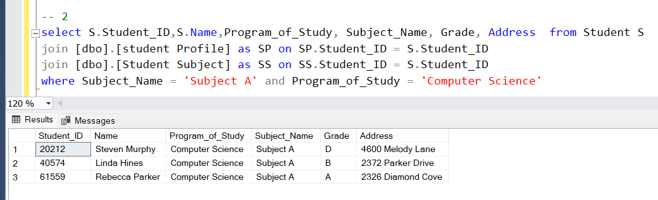

Figure 5.

**Soal No.3**

INSERT these values into student_profile table

**🡪Jawaban:**

insert into dbo.[student Profile] (Student_ID, Name,Email_Address, Phone, Address, City) values

('29361', 'Glen Chavez','Chavez_Glen@xfinity.com', '702-737-4764','2965 Jacobs Street','Pittsburgh' ),

('83604','Kimberly Ashley','Kimberly_Ashley@comcast.net','853-862-3087','4998 Benedum Drive','Kingston'),

('57784','Robert Jones','Jones.Robert@outlook.com','928-868-4951','4998 Benedum Drive','Kingston'),

('23489','Amber Williams','AmberWilliams17@mail.com','713-575-2422','4600 Melody Lane','Richmond'),

('26678','Bryan Benson','Bryan_Benson@protonmail.com','358-767-5696','2094 Biddie Lane','Richmond'),

('52345','Sharon Miller','SMiller34@gmail.com','128-806-1850','3166 Single Street','Kingston'),

('88643','William Franco','Franco_William@yahoo.com','588-420-6039','4600 Melody Lane','Richmond'),

('57823','Gregory Johnson','Gregory.J@comcast.net','653-480-0263','3901 Single Street','Kingston'),

('67209','Laurie Ward','Laurie.Ward19@att.com','299-960-5941','2953 Rosebud Avenue','Little Rock'),

('13532','Laura Gilbert','Gilbert_Laura@att.com','359-490-1979','2372 Parker Drive','Cleveland')

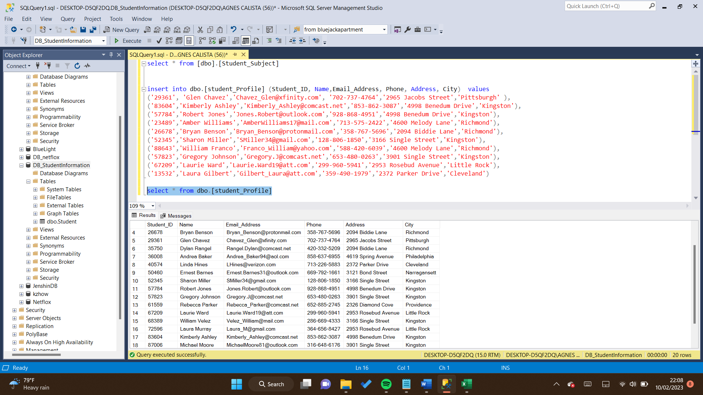

Figure 6

**Soal No.4:**

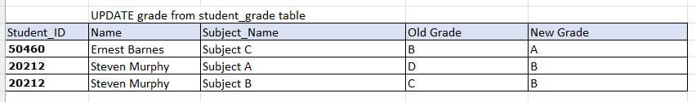

**🡪 Jawaban :**

UPDATE dbo.[Student_Grade]

SET Grade = 'A'

WHERE Subject_Name = 'Subject C' and Student_ID = '50460';

UPDATE dbo.[Student_Grade]

SET Grade = 'B'

WHERE Subject_Name = 'Subject A' and Student_ID = '20212';

UPDATE dbo.[Student_Grade]

SET Grade = 'B'

WHERE Subject_Name = 'Subject B' and Student_ID = '20212';

**Soal NO 5:**

Figure 7.

**🡪 Jawaban:**

select S.Student_ID, S.Name, SG.Subject_Name, SG.Grade, SP.Address, SP.City from Student S

join [dbo].[Student_Grade] as SG on SG.Student_ID = S.Student_ID

join [dbo].[student_Profile] as SP on SP.Student_ID = S.Student_ID

where Subject_Name = 'Subject B' and Grade = 'A' and City IN (select City from [dbo].[student_Profile] where City = 'Kingston')

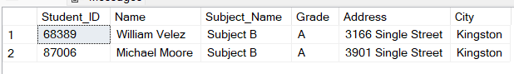

Figure 8.

**Soal NO.6:**

**Figure 9.**

**🡪 Jawaban :**

select SP.Student_ID, SP.Name, Email_Address

from [dbo].[student_Profile] SP

join Student on Student.Student_ID = SP.Student_ID

where Email_Address like '%@outlook%'

**Figure 10.**